**Programming Fundamentals I – Final Project**

**Analysis**

When the program is first run you have to input how many rows the plane will have and how much the one-way ticket will cost.  
Only integer rows will be accepted and for the cost all numbers will be accepted for the value, if a negative value is typed, the number assigned will be the absolute value of the number.

After both values are inputted correctly a menu will be printed to the screen, with four options:

1. Buy Tickets.
2. Check Tickets.
3. Cancel Tickets.
4. Exit the program.

In order to select one of the four options introduce the corresponding numbers assigned to them, any input below 1 or above 4 will have no effect in the program and another value will be asked.

* If number 1 is selected the number of tickets will be asked greater than the number of seats available.
  + After this value is entered correctly the desired seat will be asked in the plane, how the value is entered doesn’t matter while the order of the digits are not changed.  
    The allowed range will be specified in the program.  
    Then, you will be asked if you want a return ticket and if any luggage will be carried luggage, simply input “yes” or “y” to confirm, or anything else to reject.
    - If luggage is carried you will be asked for how many luggage you will carry, only integer numbers will be accepted and if a negative value is typed its absolute value will be used.
  + This process will be repeated until all the tickets specified are bought, when this process ends the price will be printed and you will be returned to the menu.
* If number 2 is selected a seat to be checked will be asked, the range accepted will be printed in the screen, the status of the seat will be then printed.
* If number 3 is selected the seat to be cancelled will be asked, the range allowed will be shown in the screen, after entering the seat desired you have to confirm you want to cancel that seat, type “yes” or “y” if you really want to cancel it, anything else to not cancel it.
* If number 4 is typed a confirmation will be done in order to exit the program, type “yes” or “y” to exit the program, anything else to not exit the program.

**Design**

**Structure diagram**

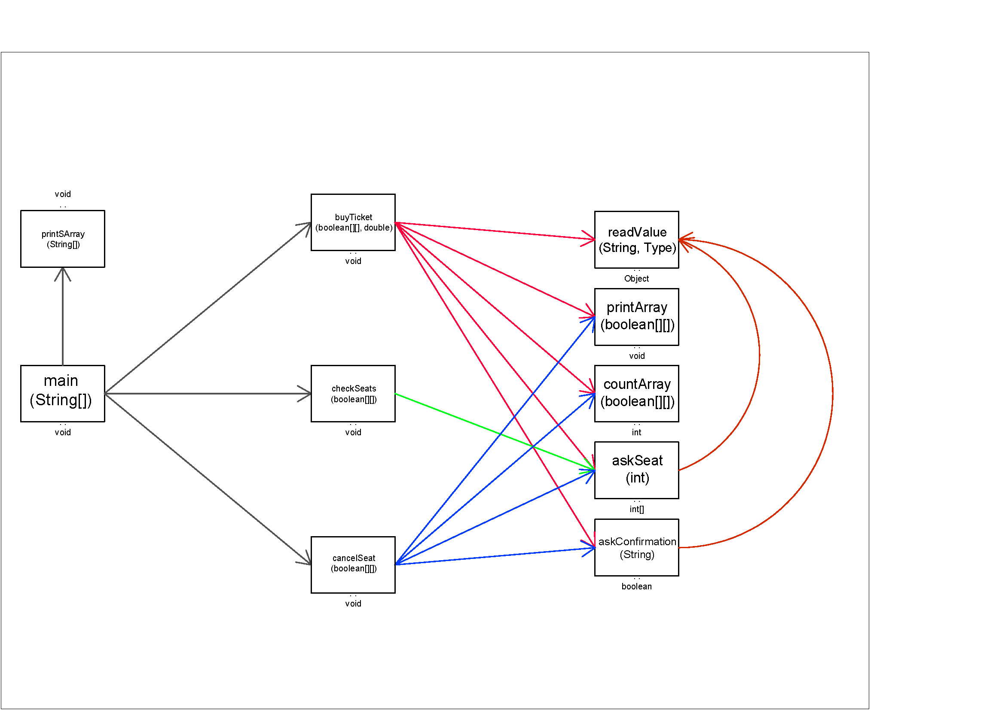

**Pseudocode**

There’s a copy of the pseudocode in the .zip file.

Begin main()

numberOfRows <- readValue("How many rows are there in the plane?", Whole_Number)

priceOfTicket <- readValue("How much does the one-way ticket costs?", Real_Number)

stop <- false

seats <- null

Do

printSArray(("What do you want to do?", "1: Buy tickets", "2: Check", 3: Cancel tickets", "4: Exit the program"))

action <- readValue("", Whole_Number)

Switch (action)

value 1:

seats <- buyTicket(seats, priceOfTicket)

value 2:

value 3:

seats <- cancelSeat(seats)

value 4:

If(askConfirmation("Are you sure you want to exit the program?") = true) Then

stop <- true

End_If

End_Switch

While (NOT stop)

End main()

Begin printArray(inSeats)

Write("This is the layout of the plane." & "\n")

For (i <- 0) while (i < inSeats.dimension0)

For (j <- 0) while (j < inSeats.dimension1)

If inSeats(i)(j) = true Then

Write ("X")

Else

foo <- IntegerToChar(j+65)

Write (i+1 & foo & " ")

End_If

j <- j + 1

End_For

Write NewLine

i <- i + 1

End_For

Write NewLine

End_printArray

Begin askSeat(inNumberOfRows)

error <- false

row <- 0

column <- 0

Do

digits <- ""

letters <- ""

seat <- ToUpperCase(readValue("Insert the number of the seat (1 - " & inNumberOfRows & ") (A - D):", Sentence))

cseat <- ToCharacterArray(seat)

For i <- 0 while i < Length(cseat)

If (cseat(i) > 47) AND (cseat(i) < 58) Then

digits <- digits & cseat(i)

error <- false

Else

If (cseat(i) > 65) AND (cseat(i) < 69)

letters <- letters & toString(cseat(i))

error <- false

Else

error <- true

EXIT_IF

End_If

End_If

If error = true

Write ("The seat entered is not valid")

Else

row <- ToWholeNumber(digits) - 1

column <- ToASCII(CharacterPosition(0)InSentence(letters) - 65)

i <- i + 1

While (error = true)

return (row,column)

End_askSeat

Begin cancelSeat(inSeats)

If countArray(inSeats, true) = 0 Then

Write ("All the seats are empty")

Else

printArray (inSeats)

Write ("Which seat do you want to cancel?" & NEWLINE)

seat = askSeat(Length(inSeats))

If NOT (inSeats(seat(0), seat(1))) = true Then

Write("Error, that seat is empty.")

Else

If askConfirmation("Are you sure you want to cancel that seat?") = true Then

inSeats(seat(0), seat(1)) = false;

Write ("Seat cancelled succesfully")

End_If

End_If

End_If

cancelSeat <- inSeats

End_cancelSeat

Begin buyTicket(inSeats, inPriceOfTicket)

If countArray(inSeats, false) = 0 Then

Write ("All the seats are busy.")

Else

finalPrice <- 0

tickets <- 0

numberOfSeats <- countArray(inSeats,false)

Do

tickets <- readValue("How many tickets do you want to buy?", Whole_Number)

If (tickets > 10) OR (tickets < 0) OR (tickets > numberOfSeats) Then

Write ("The number of tickets entered is not valid.")

Else

If tickets > 5 Then

discount <- true

Else

discount <- false

count <- tickets

While (count > 0)

Write ("Ticket " & (tickets - count + 1)

printArray (inSeats)

seat <- askSeat(Length(inSeats))

If inSeats(seat(0), seat(1)) = true Then

Write ("Sorry, that seat is already bought.")

Else

If askConfirmation("Do you want to buy a return ticket?") = true Then

price <- inPriceOfTicket * 1.5

Else

price <- inPriceOfTicket

End_If

End_If

If askConfirmation("Will you carry any luggage?") = true Then

luggage <- readValue("How many will you carry?", Whole_Number)

End_If

finalPrice <- finalPrice + price + luggage * 15

inSeats(seat(0), seat(1)) = true

count <- count - 1

End_While

End_If

While ((tickets > 10) OR (tickets < 0) OR (tickets > numberOfSeats))

End_If

buyTicket <- inSeats

End_buyTicket

Begin checkSeats(inSeats)

foo = askSeat(Length(inSeats)

If inSeats(foo(0) foo(1)) = true

Write ("That seat is busy")

Else

Write ("That seat is empty")

End_If

End_checkSeats

Begin printSArray(text)

For i <- 0 while i < Length(text)

Write text(i)

i <- i + 1

End_For

End_printSArray

Begin askConfirmation(prompt)

confirmation <- ToLowerCase(readValue(prompt, Sentence))

If (confirmation) = "yes" OR (confirmation) = "y" Then

return true

Else

return false

End_If

End_askConfirmation

Begin countArray(inSeats, flag)

For i <- 0 while i < dimension0(inSeats)

For j <- 0 while j < dimension1(inSeats)

If inSeats(i, j) = flag Then

count <- count + 10

End_If

j <- j + 10

End_For

i <- i + 1

End_For

End_countArray

Begin readValue(prompt, type)

Write prompt

Switch type

value Whole_Number:

result <- readWhole

value Real_Number:

result <- readReal

value Sentence:

result <- readSentence

End_Switch

End_readValue

**User manual**

To run the program you have to go the command prompt, press Windows+R, then type “cmd” and press Enter.

Navigate to where the .java file is located using the “cd” command followed by the route of the file.

After navigating to the file type “javac” followed by a blank space and the name of the file with its extension.

Afterwards, type “java” followed by a blank space and the name of the file, this time without the extension, when you press enter the program will start to run.

Córdoba Romero, Javier

García Castellanos, Javier